# **Team name - Girls Squad Punam Nagrale, Raga Rasagna Paruchuri, Ramya Rao Thella, Smriti Kumari**

# **Module 1 - Playstore Apps analysis**

1. Which apps have the highest rating in the given available dataset?

**SELECT** App **AS** top_apps, Rating

**FROM** playstore_apps

**WHERE** Rating = 5;

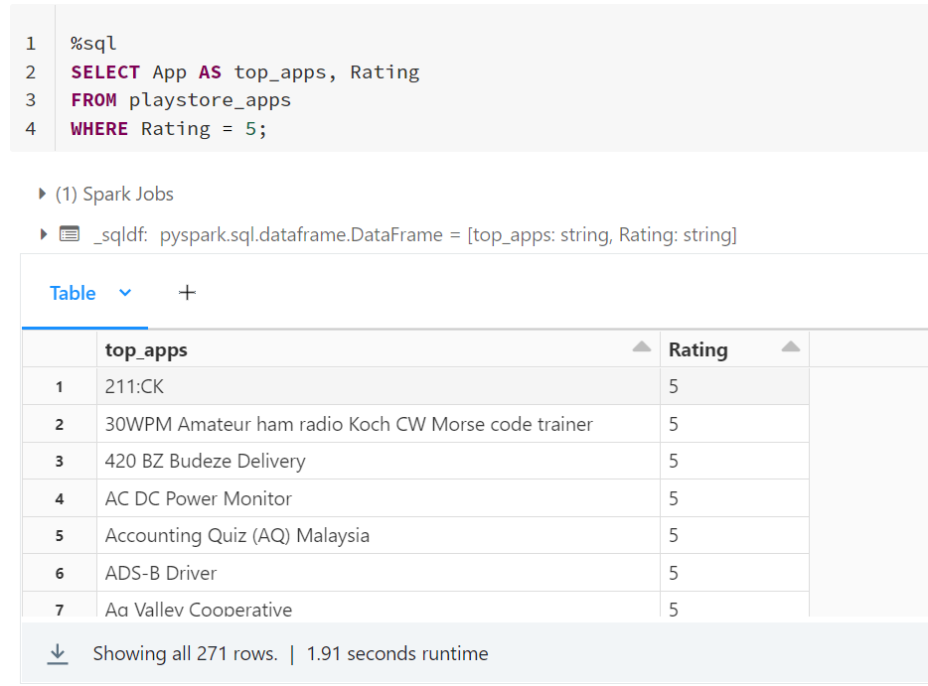

1. What are the number of installs and reviews for the above apps? Return the apps with the highest reviews to the top.

**SELECT** App, Installs, Reviews

**FROM** apps.Playstore_apps

**WHERE** Rating = 5

**ORDER BY** Reviews **DESC**;

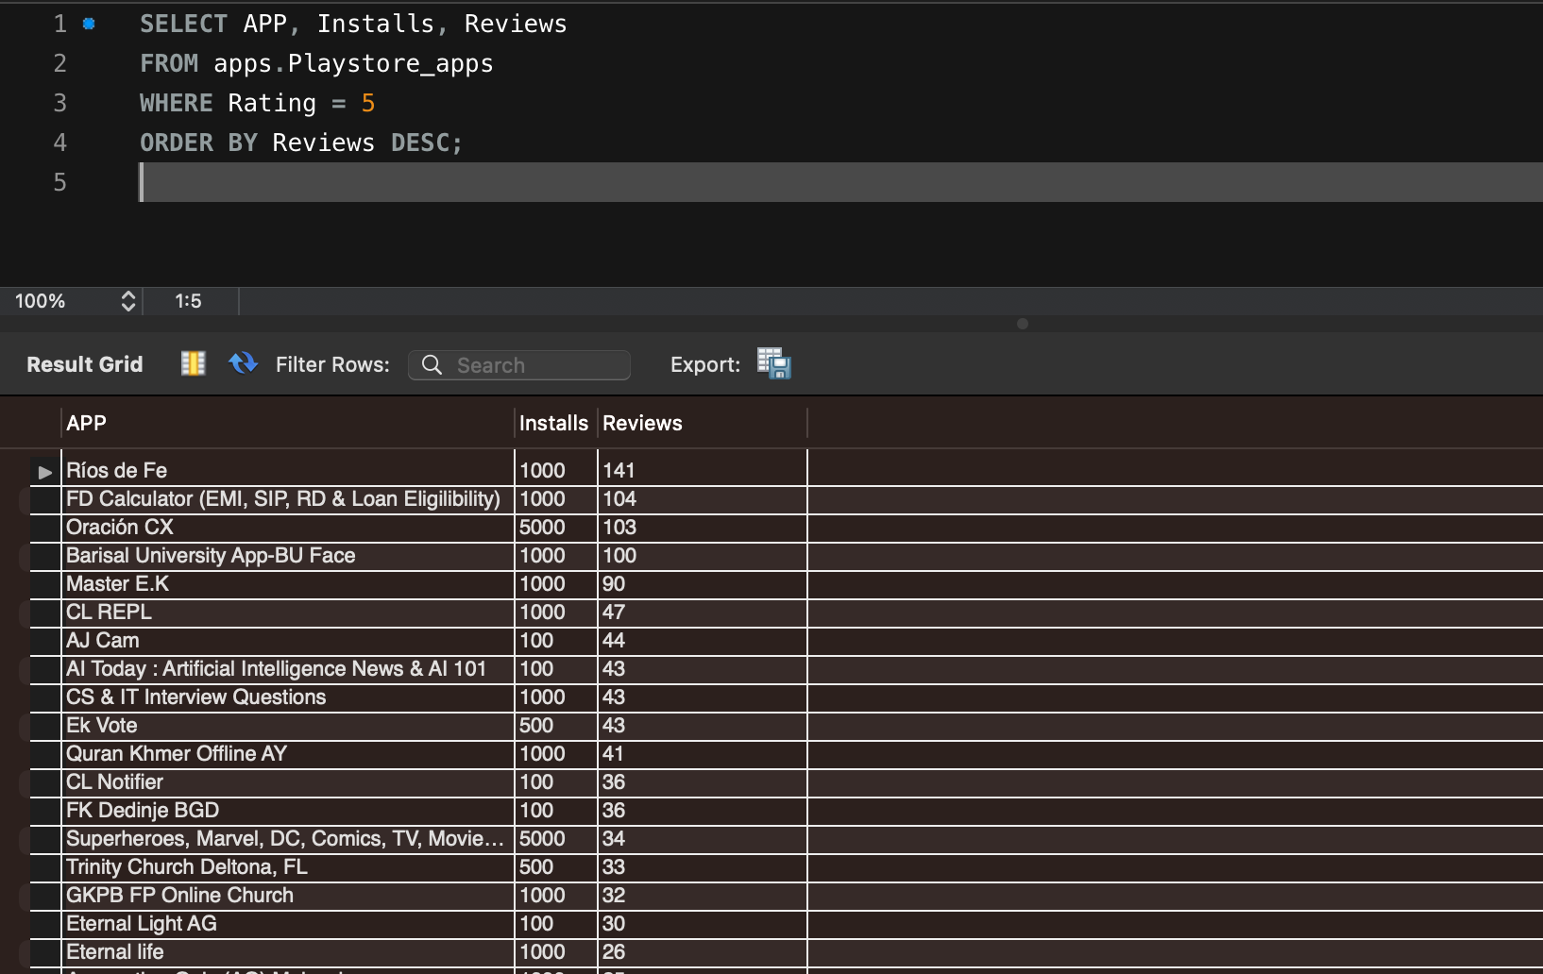

1. Which app has the highest number of reviews? Also, mention the number of reviews and category of the app

**SELECT** App, Reviews, Category

**FROM** apps.Playstore_apps

**ORDER BY** Reviews **DESC**

**LIMIT** 1;

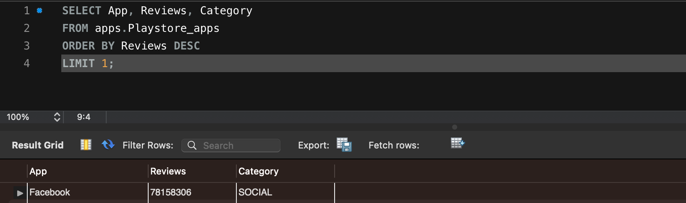

1. What is the total amount of revenue generated by the google play store by hosting apps? (Whenever a user buys apps from the google play store, the amount is considered in the revenue)

**SELECT ROUND**(**SUM**(Price * Installs),2) **AS** total_revenue

**FROM** apps.Playstore_apps

**WHERE** Type = “Paid”;

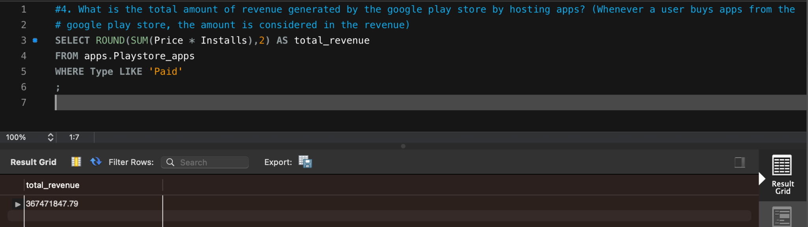

1. Which Category of google play store apps has the highest number of installs? also, find out the total number of installs for that particular category.

**SELECT** Category, **SUM**(Installs) **AS** total_installs

**FROM** apps.Playstore_apps

**GROUP BY** Category

**ORDER BY** total_installs **DESC**

**LIMIT** 1;

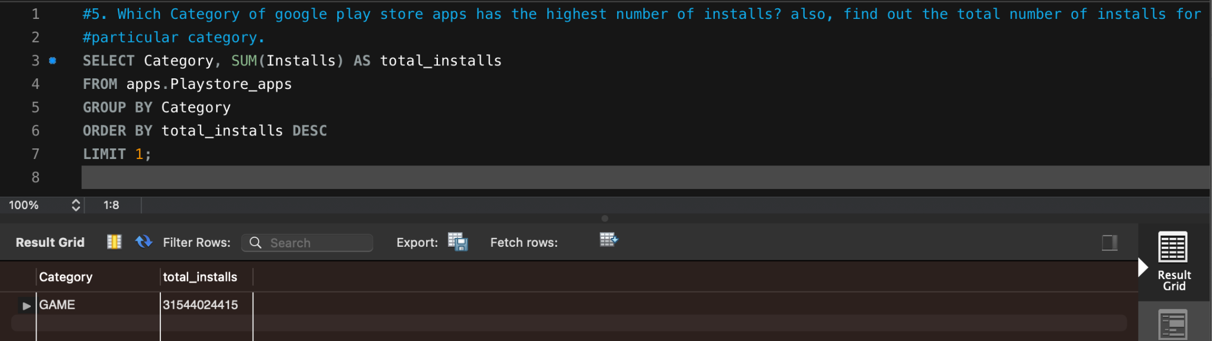

1. Which Genre has the most number of published apps?

**SELECT** Genres, **COUNT**(Genres) **AS** total_apps

**FROM** apps.Playstore_apps

**GROUP BY** Genres

**ORDER BY** total_apps **DESC**

**LIMIT** 1;

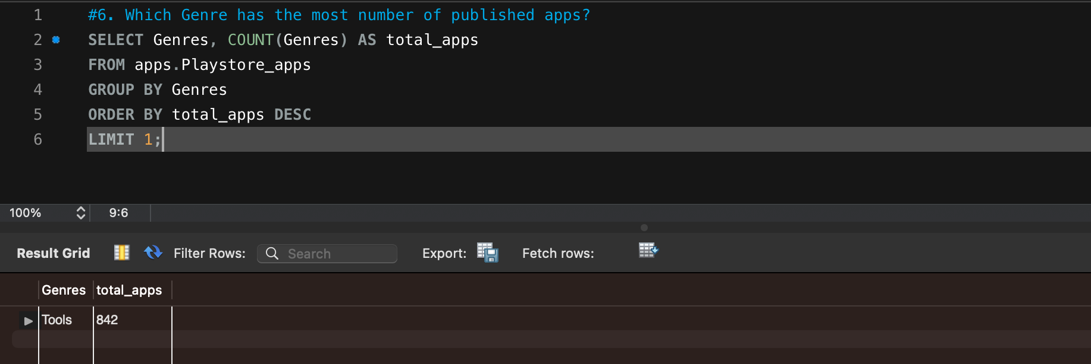

1. Provide the list of all games ordered in such a way that the game that has the highest number of installs is displayed on the top (to avoid duplicate results use distinct)

**SELECT DISTINCT** App, Installs

**FROM** playstore_apps

**WHERE** Category = “GAME”

**ORDER BY** Installs **DESC**;

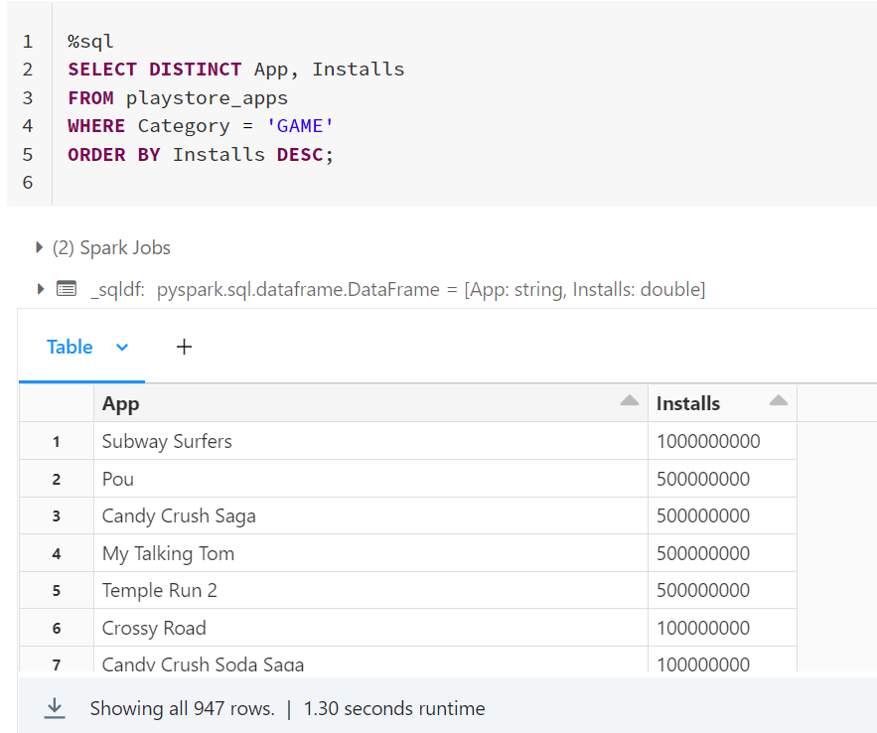

8. Provide the list of apps that can work on android version 4.0.3 and UP.

1. **android version ‘4.0.3 and UP’**

**SELECT** App, `Android Ver`

**FROM** playstore_apps

**WHERE** `Android Ver` = “4.0.3 and up”;

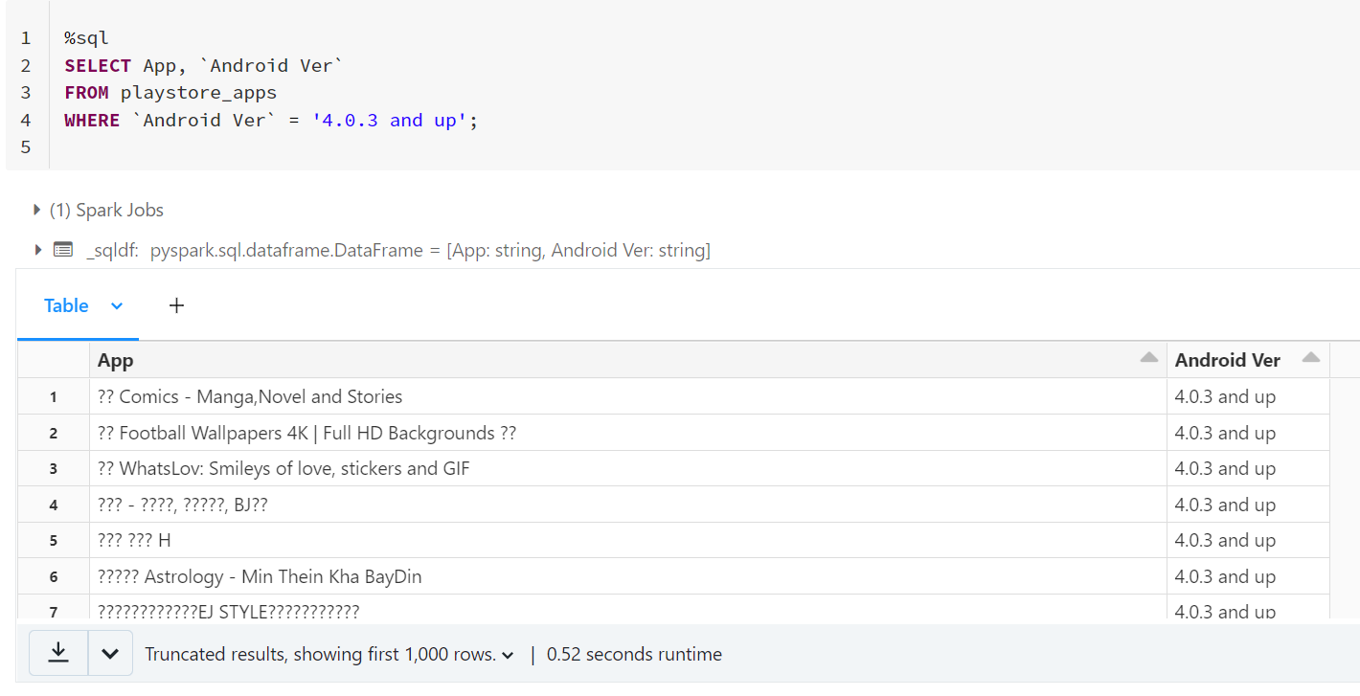

1. **All android versions including ‘4.0.3 and UP’ and above**

**SELECT** App, `Android Ver`

**FROM** playstore_apps

**WHERE** `Android Ver`<> “4.0 and up”

**AND** `Android Ver` **LIKE** “4%”

**OR** `Android Ver` **LIKE** “5%”

**OR** `Android Ver` **LIKE** “6%”

**OR** `Android Ver` **LIKE** “7%”

**OR** `Android Ver` **LIKE** “8%”

**ORDER BY** `Android Ver`;

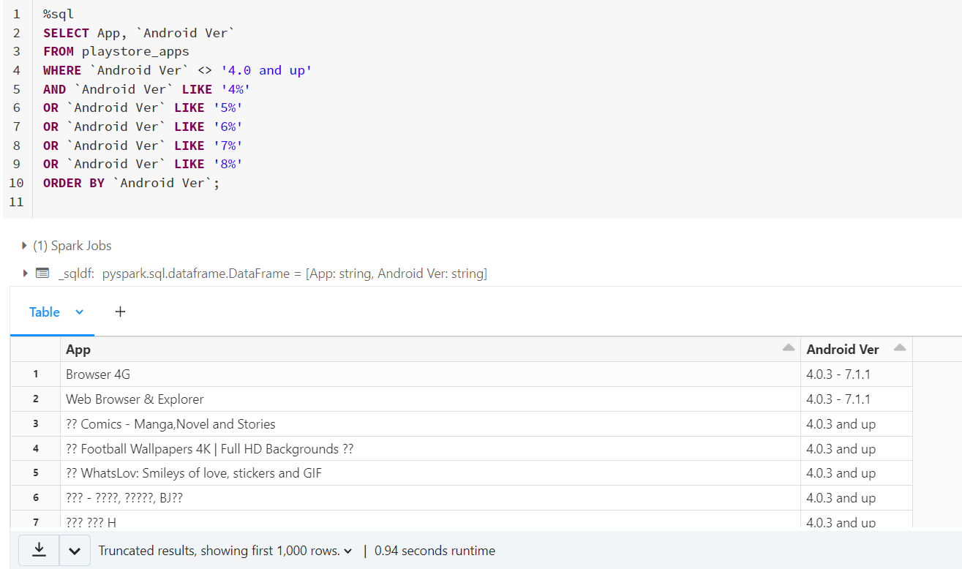

9. How many apps from the given data set are free? Also, provide the number of paid apps.

**SELECT** **COUNT**(App) **AS** total_free_apps

**FROM** playstore_apps

**WHERE** Type = “Free”;

**SELECT** **COUNT**(App) **AS** total_paid_apps

**FROM** playstore_apps

**WHERE** Type = “Paid”;

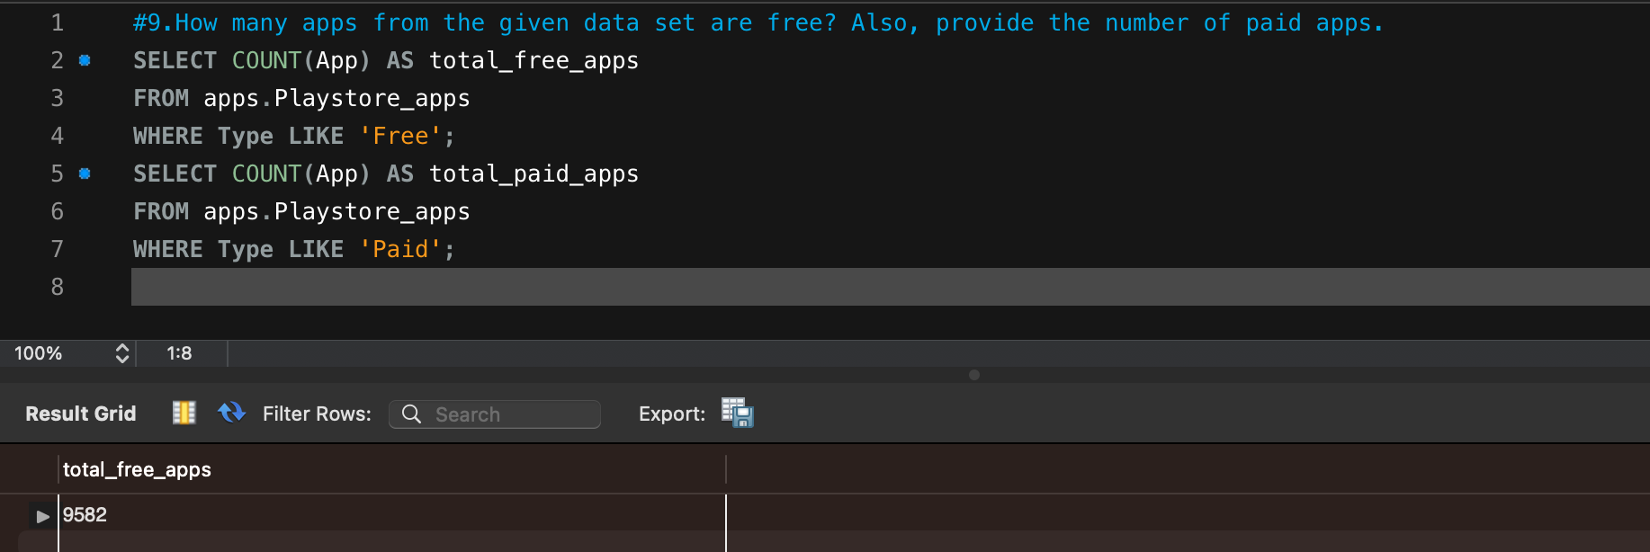

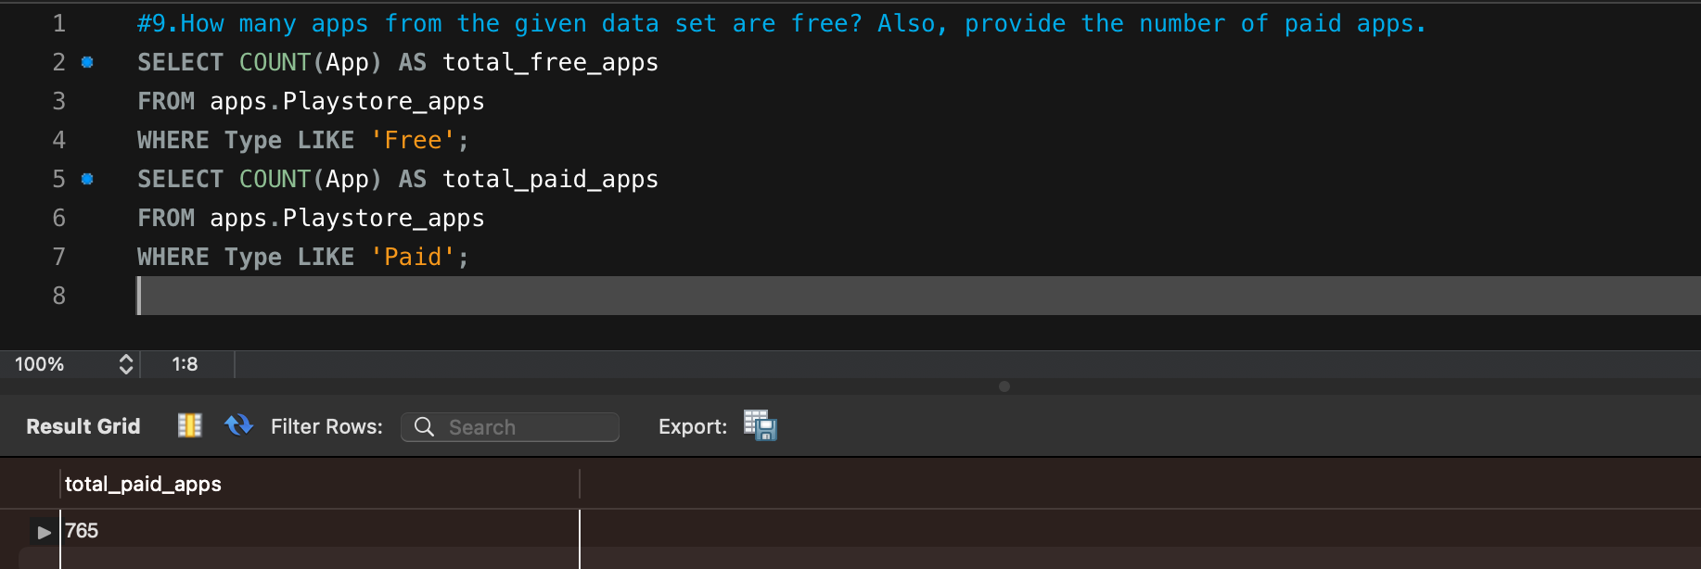

10. Which is the best dating app? (Best dating app is the one having the highest number of Reviews)

**SELECT** App **AS** best_dating_app, Reviews **AS** total_reviews

**FROM** apps.Playstore_apps

**WHERE** Category = “DATING”

**ORDER BY** Reviews **DESC**

**LIMIT** 1;

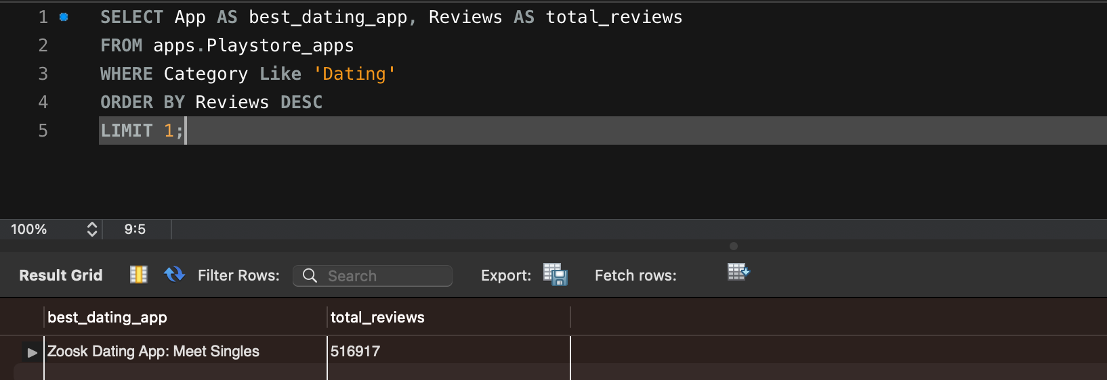

11. Get the number of reviews having positive sentiment and number of reviews having negative sentiment for the app **10 best foods for you** and compare them.

**SELECT** Sentiment, **COUNT**(Sentiment) **AS** Total_Count

**FROM** reviews

**WHERE** App **LIKE** “10 best foods for you”

**AND** (Sentiment = “Positive” **OR** Sentiment = “Negative”)

**GROUP BY** Sentiment;

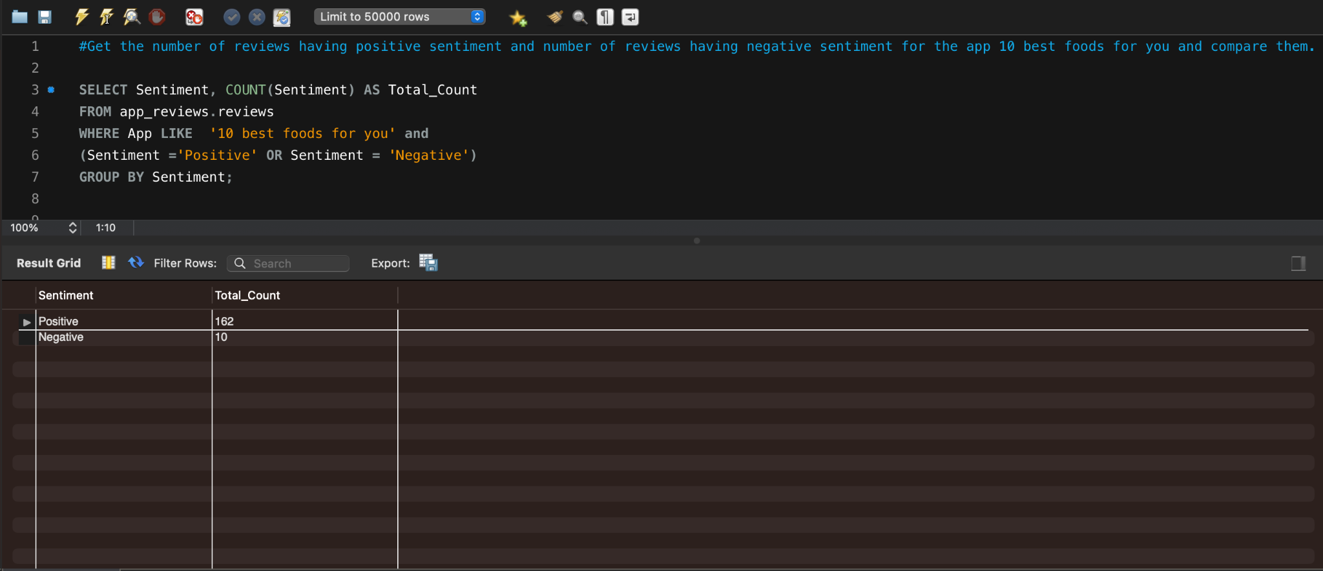

12. Which comments of **ASUS SuperNote** have sentiment polarity and sentiment subjectivity both as 1?

**SELECT** Translated_Review

**FROM** reviews

**WHERE** App **LIKE** 'ASUS SuperNote'

**AND** Sentiment_Polarity = 1

**AND** Sentiment_Subjectivity = 1;

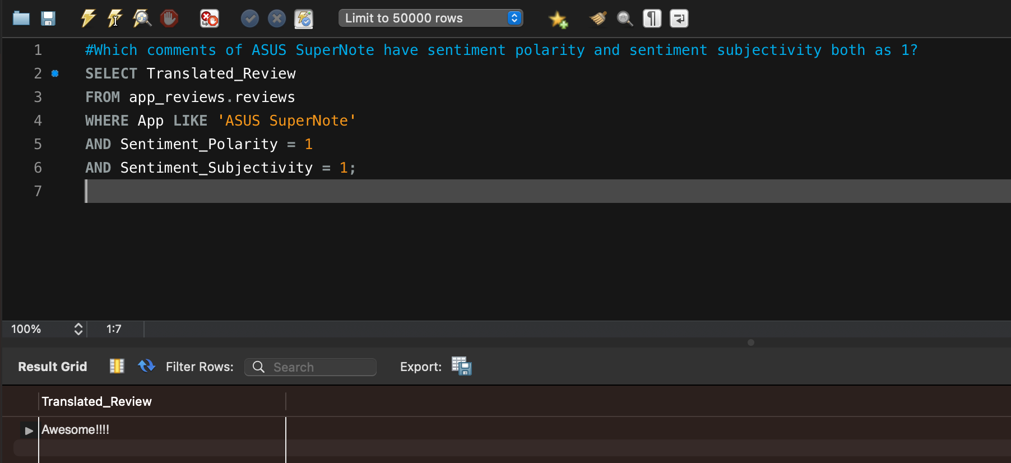

13. Get all the neutral sentiment reviews for the app **Abs Training-Burn belly fat**

**SELECT** Translated_Review

**FROM** reviews

**WHERE** Sentiment **LIKE** “Neutral”

**AND** App **LIKE** “Abs Training-Burn belly fat”;

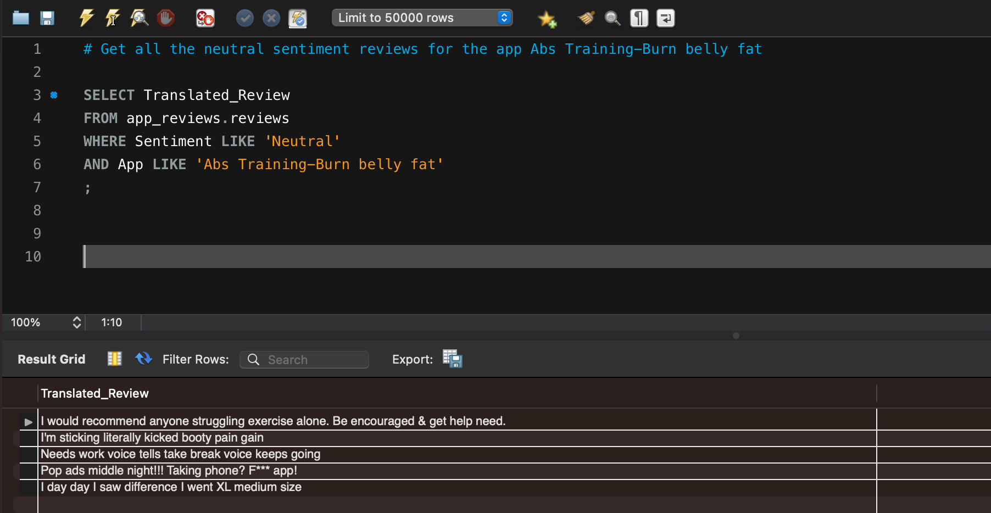

14. Extract all negative sentiment reviews for **Adobe Acrobat Reader** with their sentiment polarity and sentiment subjectivity

**SELECT** Translated_Review, Sentiment_Polarity, Sentiment_Subjectivity

**FROM** reviews

**WHERE** App **LIKE** “Adobe Acrobat Reader”

**AND** Sentiment = “Negative”;

